**Week 7 – React Superset Id : 6431499**

**Name : Balaji V**

**Exercise 1 : Create Cricket App using React**

**Code:**

**IndianPlayers.js**

function OddPlayers(first,third,fifth){

return(

<div>

<li>First : {first}</li>

<li>Third : {third}</li>

<li>Fifth : {fifth}</li>

</div>

);

}

const IndianPlayers=()=>{

const T20Players=['First Player','Second Player','Third Player'];

const RanjiTrophyPlayers=['Fourth Player','Fifth Player','Sixth Player'];

const IndianPlayers=[...T20Players, ...RanjiTrophyPlayers];

const oddPlayersData=['Sachin1','Virat3','Yuvaraj5'];

const evenPlayersData=['Dhoni2','Rohit4','Raina6'];

return(

<div className="container">

<div className="section">

<h2>Odd Players</h2>

<ul>

{OddPlayers(oddPlayersData[0], oddPlayersData[1], oddPlayersData[2])}

</ul>

</div>

<div className="section">

<h2>Even Players</h2>

<ul>

{evenPlayersData.map((player,index)=>(

<li key={index}>

{index===0 ? 'Second' : index===1 ? 'Fourth' : 'Sixth'} : {player}

</li>

))}

</ul>

</div>

<div className="section">

<h2>List of Indian Players Merged:</h2>

<ul>

{IndianPlayers.map((player,index)=>(

<li key={index}>Mr. {player}</li>

))}

</ul>

</div>

</div>

);

};

export default IndianPlayers;

**ListofPlayers.js:**

const ListofPlayers=()=>{

const players=[

{name:'Jack',score:50},

{name:'Michael',score:70},

{name:'John',score:40},

{name:'Ann',score:61},

{name:'Elisabeth',score:61},

{name:'Sachin',score:95},

{name:'Dhoni',score:100},

{name:'Virat',score:84},

{name:'Jadeja',score:64},

{name:'Raina',score:75 },

{ name: 'Rohit',score:80}

];

const players70=[];

players.map((item)=>{

if(item.score<=70){

players70.push(item);

}

return null;

});

return(

<div className="container">

<div className="section">

<h2>List of Players</h2>

<ul>

{players.map((item)=>(

<li key={item.name}>

Mr. {item.name} {item.score}

</li>

))}

</ul>

</div>

<div className="section">

<h2>List of Players having Scores Less than 70</h2>

<ul>

{players70.map((item)=>(

<li key={item.name}>

Mr. {item.name} {item.score}

</li>

))}

</ul>

</div>

</div>

);

};

export default ListofPlayers;

**App.js:**

import './App.css';

import { useState } from 'react';

import ListofPlayers from './components/ListofPlayers';

import IndianPlayers from './components/IndianPlayers';

function App(){

const [flag,setFlag]=useState(true);

const toggleFlag=()=>{

setFlag(!flag);

};

return(

<div className="App">

<header className="App-header">

<h1>Cricket Application</h1>

<button className="toggle-btn" onClick={toggleFlag}>

{flag ? 'Show Indian Players' : 'Show List of Players'}

</button>

</header>

<main className="App-main">

{flag ? <ListofPlayers /> : <IndianPlayers />}

</main>

</div>

);

}

export default App;

**App.css:**

@import url('https://fonts.googleapis.com/css2?family=Roboto+Slab:wght@300;400;500;600;700&display=swap');

*{

margin: 0;

padding: 0;

box-sizing: border-box;

}

body{

font-family: 'Roboto Slab', serif;

background: linear-gradient(135deg, #1e3c72 0%, #2a5298 100%);

min-height: 100vh;

color: #333;

}

.App{

min-height: 100vh;

display: flex;

flex-direction: column;

}

.App-header{

background: rgba(255, 255, 255, 0.95);

backdrop-filter: blur(10px);

padding: 2rem;

text-align: center;

box-shadow: 0 4px 20px rgba(0, 0, 0, 0.1);

border-bottom: 3px solid #1e3c72;

}

.App-header h1{

color: #1e3c72;

font-size: 2.5rem;

font-weight: 700;

margin-bottom: 1rem;

text-shadow: 2px 2px 4px rgba(0, 0, 0, 0.1);

}

.toggle-btn{

background: linear-gradient(45deg, #1e3c72, #2a5298);

color: white;

border: none;

padding: 12px 30px;

font-size: 1.1rem;

font-family: 'Roboto Slab', serif;

font-weight: 500;

border-radius: 50px;

cursor: pointer;

transition: all 0.3s ease;

box-shadow: 0 4px 15px rgba(30, 60, 114, 0.3);

}

.toggle-btn:hover{

transform: translateY(-2px);

box-shadow: 0 6px 20px rgba(30, 60, 114, 0.4);

background: linear-gradient(45deg, #2a5298, #1e3c72);

}

.toggle-btn:active{

transform: translateY(0);

}

.App-main{

flex: 1;

padding: 2rem;

display: flex;

justify-content: center;

align-items: flex-start;

}

.container{

background: rgba(255, 255, 255, 0.95);

backdrop-filter: blur(10px);

border-radius: 20px;

padding: 2rem;

box-shadow: 0 10px 40px rgba(0, 0, 0, 0.2);

max-width: 800px;

width: 100%;

border: 1px solid rgba(255, 255, 255, 0.3);

}

.section{

margin-bottom: 2.5rem;

}

.section:last-child{

margin-bottom: 0;

}

.section h2{

color: #1e3c72;

font-size: 1.8rem;

font-weight: 600;

margin-bottom: 1.5rem;

padding-bottom: 0.5rem;

border-bottom: 3px solid #1e3c72;

text-align: center;

}

.section ul{

list-style: none;

padding: 0;

}

.section li{

background: linear-gradient(90deg, rgba(30, 60, 114, 0.1), rgba(42, 82, 152, 0.05));

margin: 0.8rem 0;

padding: 1rem 1.5rem;

border-radius: 10px;

border-left: 4px solid #1e3c72;

font-size: 1.1rem;

font-weight: 400;

color: #2c3e50;

transition: all 0.3s ease;

position: relative;

overflow: hidden;

}

.section li::before{

content: '';

position: absolute;

left: 0;

top: 0;

height: 100%;

width: 0;

background: linear-gradient(90deg, rgba(30, 60, 114, 0.1), rgba(42, 82, 152, 0.1));

transition: width 0.3s ease;

z-index: -1;

}

.section li:hover{

transform: translateX(5px);

box-shadow: 0 4px 15px rgba(30, 60, 114, 0.2);

}

.section li:hover::before{

width: 100%;

}

@media(max-width: 768px){

.App-header{

padding: 1.5rem;

}

.App-header h1{

font-size: 2rem;

}

.toggle-btn{

padding: 10px 20px;

font-size: 1rem;

}

.App-main{

padding: 1rem;

}

.container{

padding: 1.5rem;

border-radius: 15px;

}

.section h2{

font-size: 1.5rem;

}

.section li{

padding: 0.8rem 1rem;

font-size: 1rem;

}

}

@media(max-width: 480px){

.App-header h1{

font-size: 1.5rem;

}

.toggle-btn{

padding: 8px 16px;

font-size: 0.9rem;

}

.container{

padding: 1rem;

}

.section h2{

font-size: 1.3rem;}}

**Output:**

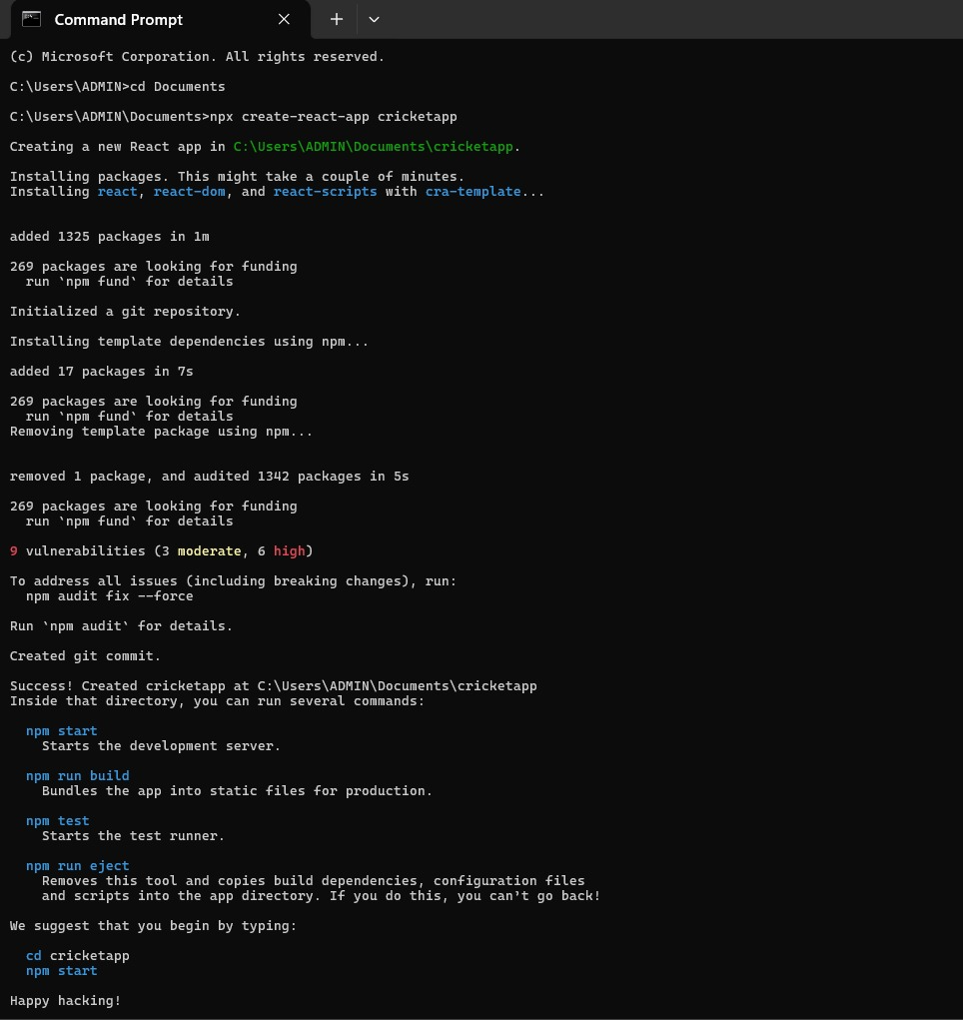

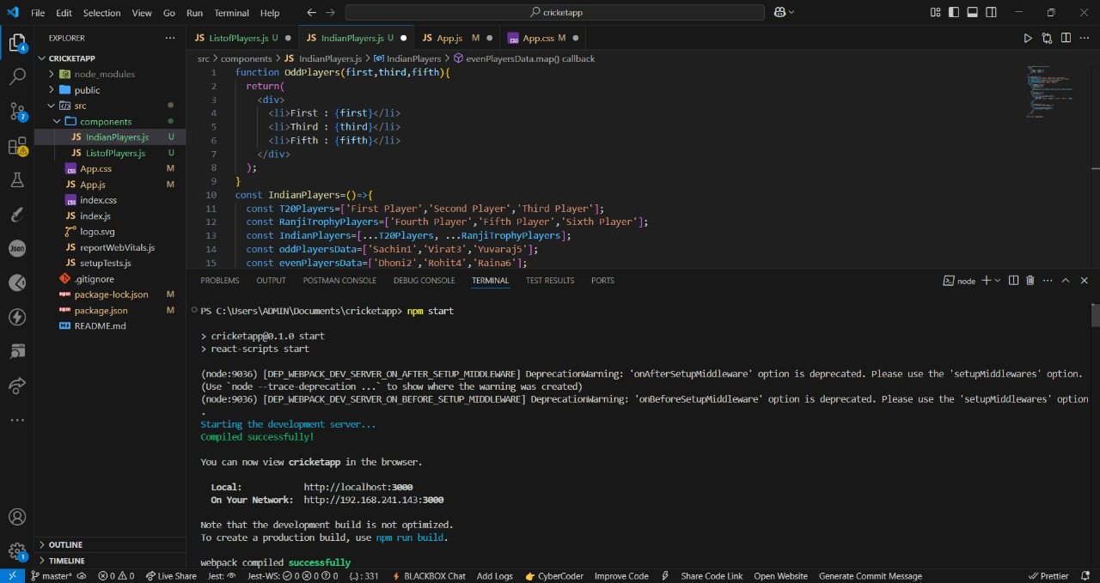

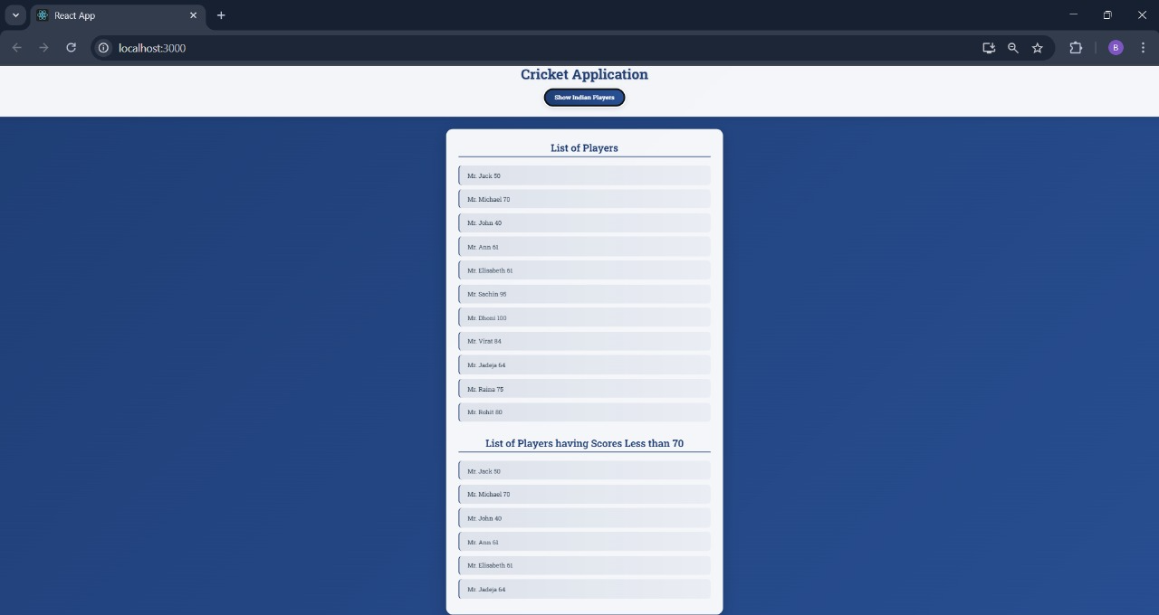

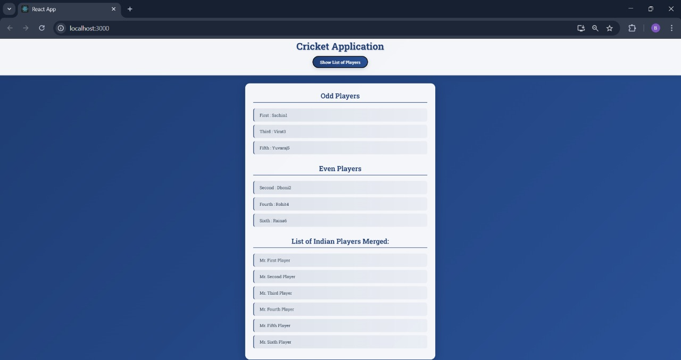

**Exercise 2 : Create Office Space Rental App using React**

**Code:**

**App.js:**

import './App.css';

const officeSpaces=[

{

id: 1,

name: "CTS",

rent: 50000,

address: "Chennai",

image: "https://i.pinimg.com/1200x/38/df/fb/38dffb05302dcf23a03e6f538a2f03a7.jpg"

},

{

id: 2,

name: "Tech Hub",

rent: 75000,

address: "Bangalore",

image: "https://images.unsplash.com/photo-1497366811353-6870744d04b2?ixlib=rb-4.0.3&ixid=M3wxMjA3fDB8MHxwaG90by1wYWdlfHx8fGVufDB8fHx8fA%3D%3D&auto=format&fit=crop&w=1000&q=80"

},

{

id: 3,

name: "Business Center",

rent: 45000,

address: "Mumbai",

image: "https://images.unsplash.com/photo-1497366754035-f200968a6e72?ixlib=rb-4.0.3&ixid=M3wxMjA3fDB8MHxwaG90by1wYWdlfHx8fGVufDB8fHx8fA%3D%3D&auto=format&fit=crop&w=1000&q=80"

},

{

id: 4,

name: "Corporate Plaza",

rent: 85000,

address: "Delhi",

image: "https://images.squarespace-cdn.com/content/v1/5f2e38b9301d9e64e13c2501/1598591377363-WBX6E6X495H898KH5PO7/image-asset.jpeg?format=1000w"

},

{

id: 5,

name: "Innovation Hub",

rent: 55000,

address: "Hyderabad",

image: "https://images.unsplash.com/photo-1497215728101-856f4ea42174?ixlib=rb-4.0.3&ixid=M3wxMjA3fDB8MHxwaG90by1wYWdlfHx8fGVufDB8fHx8fA%3D%3D&auto=format&fit=crop&w=1000&q=80"

},

{

id: 6,

name: "Executive Suites",

rent: 95000,

address: "Pune",

image: "https://images.unsplash.com/photo-1497215842964-222b430dc094?ixlib=rb-4.0.3&ixid=M3wxMjA3fDB8MHxwaG90by1wYWdlfHx8fGVufDB8fHx8fA%3D%3D&auto=format&fit=crop&w=1000&q=80"

}

];

const OfficeSpaceCard=({officeSpace})=>{

const getRentColor=(rent)=>{

return rent<=60000 ? '#e74c3c' : '#27ae60';

};

return(

<div className="office-card">

<div className="image-container">

<img src={officeSpace.image} alt={officeSpace.name} className="office-image"/>

<div className="image-overlay">

<span className="view-details">View Details</span>

</div>

</div>

<div className="card-content">

<h3 className="office-name">Name: {officeSpace.name}</h3>

<h3 className="office-rent" style={{color: getRentColor(officeSpace.rent)}}>

Rent: Rs. {officeSpace.rent.toLocaleString()}

</h3>

<h3 className="office-address">Address: {officeSpace.address}</h3>

</div>

</div>

);

};

function App(){

return(

<div className="App">

<header className="app-header">

<div className="header-content">

<h1 className="main-heading">Office Space, at Affordable Range</h1>

<p className="subtitle">Find your perfect workspace today</p>

</div>

</header>

<main className="main-content">

<div className="container">

<section className="featured-section">

<h2 className="section-title">Featured Office Space</h2>

<div className="featured-card">

<OfficeSpaceCard officeSpace={officeSpaces[0]} />

</div>

</section>

<section className="all-spaces-section">

<h2 className="section-title">All Available Office Spaces</h2>

<div className="office-grid">

{officeSpaces.map((office) => (

<OfficeSpaceCard key={office.id} officeSpace={office} />

))}

</div>

</section>

<section className="stats-section">

<div className="stats-container">

<div className="stat-item">

<h3>{officeSpaces.length}</h3>

<p>Available Spaces</p>

</div>

<div className="stat-item">

<h3>{officeSpaces.filter(office => office.rent <= 60000).length}</h3>

<p>Affordable Options</p>

</div>

<div className="stat-item">

<h3>{new Set(officeSpaces.map(office => office.address)).size}</h3>

<p>Cities Covered</p>

</div>

</div>

</section>

</div>

</main>

<footer className="app-footer">

<div className="container">

<p>&copy; 2025 Office Space Rental App. All rights reserved.</p>

</div>

</footer>

</div>

);

}

export default App;

**App.css:**

@import url('https://fonts.googleapis.com/css2?family=Roboto+Slab:wght@300;400;500;600;700;800;900&display=swap');

*{

margin: 0;

padding: 0;

box-sizing: border-box;

}

body{

font-family: 'Roboto Slab', serif;

line-height: 1.6;

color: #2c3e50;

background: linear-gradient(135deg, #667eea 0%, #764ba2 100%);

min-height: 100vh;

}

.App{

min-height: 100vh;

display: flex;

flex-direction: column;

}

.container{

max-width: 1200px;

margin: 0 auto;

padding: 0 20px;

}

.app-header{

background: linear-gradient(135deg, #1e3c72 0%, #2a5298 100%);

color: white;

padding: 80px 0;

text-align: center;

position: relative;

overflow: hidden;

}

.app-header::before{

content: '';

position: absolute;

top: 0;

left: 0;

right: 0;

bottom: 0;

background: url('data:image/svg+xml,<svg xmlns="http://www.w3.org/2000/svg" viewBox="0 0 1000 100" fill="rgba(255,255,255,0.1)"><path d="M0,0v46.29c47.79,22.2,103.59,32.17,158,28,70.36-5.37,136.33-33.31,206.8-37.5C438.64,32.43,512.34,53.67,583,72.05c69.27,18,138.3,24.88,209.4,13.08,36.15-6,69.85-17.84,104.45-29.34C989.49,25,1031.93-21.16,1000,0Z"></path></svg>') repeat-x;

background-size: 1000px 100px;

animation: wave 20s ease-in-out infinite;

}

@keyframes wave{

0%, 100% { transform: translateX(0); }

50% { transform: translateX(-50px); }

}

.header-content{

position: relative;

z-index: 2;

}

.main-heading{

font-size: 3.5rem;

font-weight: 800;

margin-bottom: 20px;

text-shadow: 2px 2px 4px rgba(0,0,0,0.3);

letter-spacing: -1px;

}

.subtitle{

font-size: 1.3rem;

font-weight: 400;

opacity: 0.9;

max-width: 600px;

margin: 0 auto;

}

.main-content{

flex: 1;

background: #f8fafc;

padding: 80px 0;

}

.section-title{

font-size: 2.5rem;

font-weight: 700;

color: #1e3c72;

text-align: center;

margin-bottom: 50px;

position: relative;

}

.section-title::after{

content: '';

position: absolute;

bottom: -10px;

left: 50%;

transform: translateX(-50%);

width: 80px;

height: 4px;

background: linear-gradient(45deg, #1e3c72, #2a5298);

border-radius: 2px;

}

.featured-section{

margin-bottom: 100px;

}

.featured-card{

display: flex;

justify-content: center;

}

.office-grid{

display: grid;

grid-template-columns: repeat(auto-fit, minmax(350px, 1fr));

gap: 40px;

margin-bottom: 80px;

}

.office-card{

background: white;

border-radius: 20px;

box-shadow: 0 20px 40px rgba(0,0,0,0.1);

overflow: hidden;

transition: all 0.4s cubic-bezier(0.175, 0.885, 0.32, 1.275);

position: relative;

}

.office-card:hover{

transform: translateY(-15px) scale(1.02);

box-shadow: 0 30px 60px rgba(0,0,0,0.2);

}

.image-container{

position: relative;

overflow: hidden;

height: 250px;

}

.office-image{

width: 100%;

height: 100%;

object-fit: cover;

transition: transform 0.6s ease;

}

.office-card:hover .office-image{

transform: scale(1.1);

}

.image-overlay{

position: absolute;

top: 0;

left: 0;

right: 0;

bottom: 0;

background: linear-gradient(135deg, rgba(30,60,114,0.8) 0%, rgba(42,82,152,0.8) 100%);

display: flex;

align-items: center;

justify-content: center;

opacity: 0;

transition: opacity 0.4s ease;

}

.office-card:hover .image-overlay{

opacity: 1;

}

.view-details{

color: white;

font-size: 1.1rem;

font-weight: 600;

padding: 12px 30px;

border: 2px solid white;

border-radius: 30px;

background: rgba(255,255,255,0.1);

backdrop-filter: blur(10px);

transition: all 0.3s ease;

}

.view-details:hover{

background: white;

color: #1e3c72;

}

.card-content{

padding: 30px;

}

.office-name, .office-rent, .office-address{

font-size: 1.2rem;

font-weight: 600;

margin-bottom: 15px;

display: flex;

align-items: center;

}

.office-name{

color: #1e3c72;

font-size: 1.4rem;

font-weight: 700;

}

.office-rent{

font-weight: 800;

font-size: 1.3rem;

}

.office-address{

color: #64748b;

font-weight: 500;

}

.stats-section{

background: linear-gradient(135deg, #1e3c72 0%, #2a5298 100%);

border-radius: 30px;

padding: 60px 40px;

margin: 80px 0;

color: white;

}

.stats-container{

display: grid;

grid-template-columns: repeat(auto-fit, minmax(200px, 1fr));

gap: 40px;

text-align: center;

}

.stat-item h3{

font-size: 3rem;

font-weight: 800;

margin-bottom: 10px;

background: linear-gradient(45deg, #ffffff, #e2e8f0);

-webkit-background-clip: text;

-webkit-text-fill-color: transparent;

background-clip: text;

}

.stat-item p{

font-size: 1.1rem;

font-weight: 500;

opacity: 0.9;

}

.app-footer{

background: #1a202c;

color: white;

text-align: center;

padding: 40px 0;

margin-top: auto;

}

.app-footer p{

font-weight: 400;

opacity: 0.8;

}

@media(max-width: 768px){

.main-heading{

font-size: 2.5rem;

}

.subtitle{

font-size: 1.1rem;

}

.section-title{

font-size: 2rem;

}

.office-grid{

grid-template-columns: 1fr;

gap: 30px;

}

.card-content{

padding: 25px;

}

.stats-container{

grid-template-columns: 1fr;

gap: 30px;

}

.stat-item h3{

font-size: 2.5rem;

}

}

@media (max-width: 480px){

.main-heading{

font-size: 2rem;

}

.container{

padding: 0 15px;

}

.app-header{

padding: 60px 0;

}

.main-content{

padding: 60px 0;

}

.office-card{

border-radius: 15px;

}

.image-container{

height: 200px;

}

}

@keyframes fadeInUp{

from{

opacity: 0;

transform: translateY(30px);

}

to{

opacity: 1;

transform: translateY(0);

}

}

.office-card{

animation: fadeInUp 0.6s ease forwards;

}

.office-card:nth-child(2) { animation-delay: 0.1s; }

.office-card:nth-child(3) { animation-delay: 0.2s; }

.office-card:nth-child(4) { animation-delay: 0.3s; }

.office-card:nth-child(5) { animation-delay: 0.4s; }

.office-card:nth-child(6) { animation-delay: 0.5s; }

**index.css:**

body{

margin: 0;

font-family: 'Roboto Slab', serif;

-webkit-font-smoothing: antialiased;

-moz-osx-font-smoothing: grayscale;

}

code{

font-family: source-code-pro, Menlo, Monaco, Consolas, 'Courier New',

monospace;

}

**Output:**

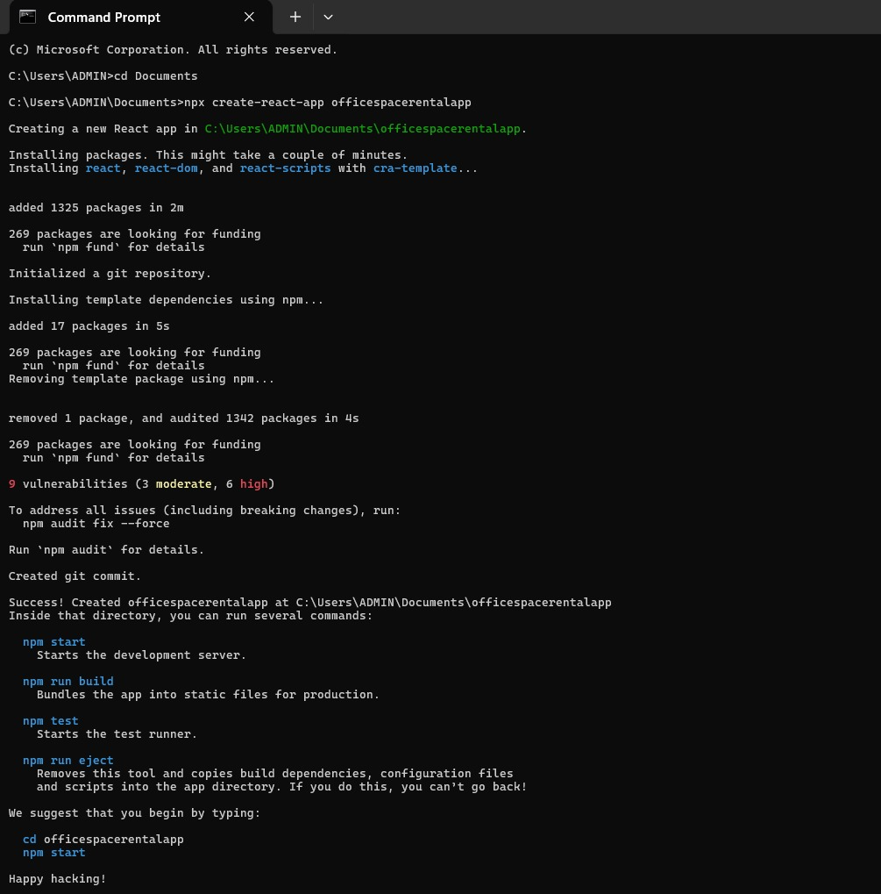

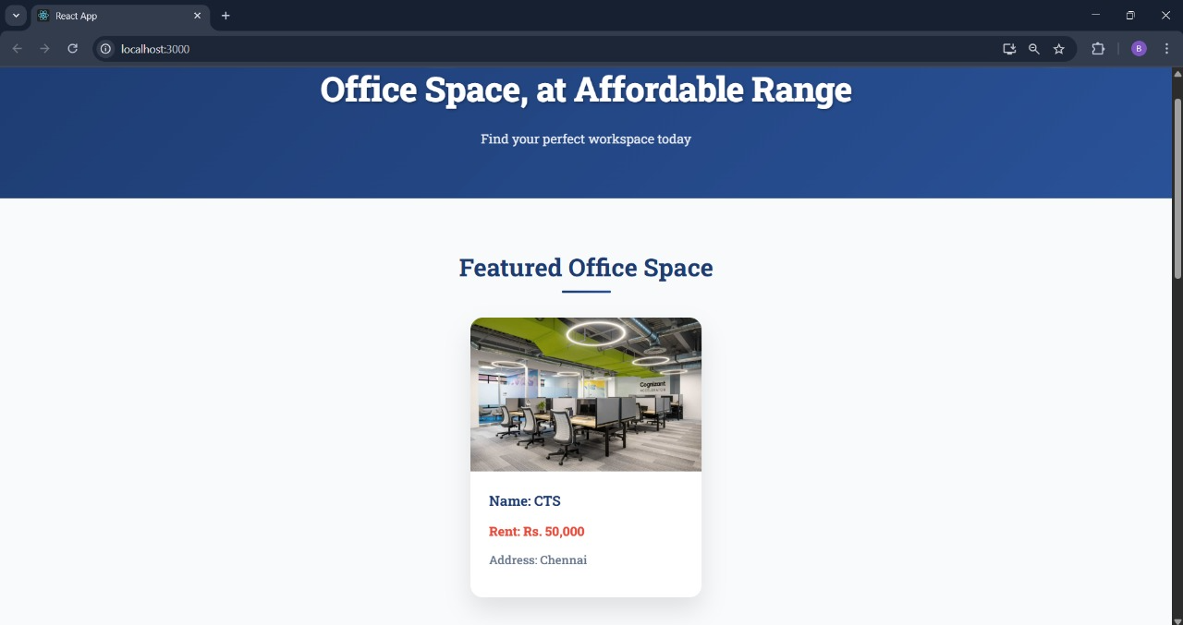

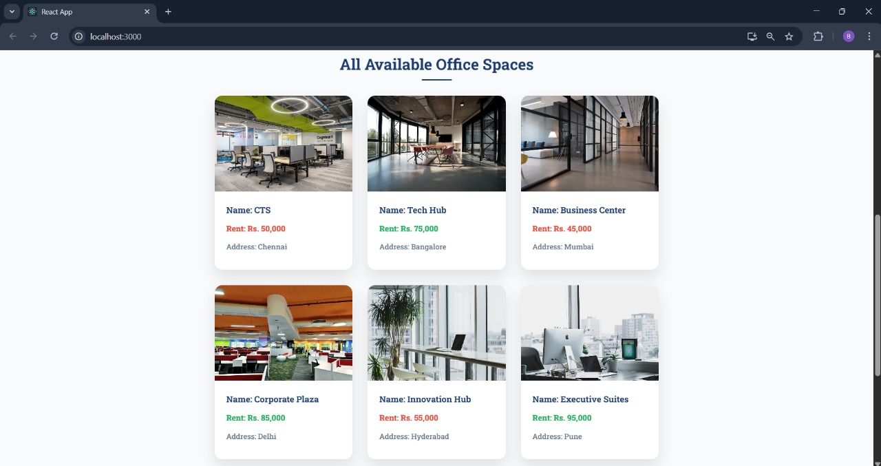

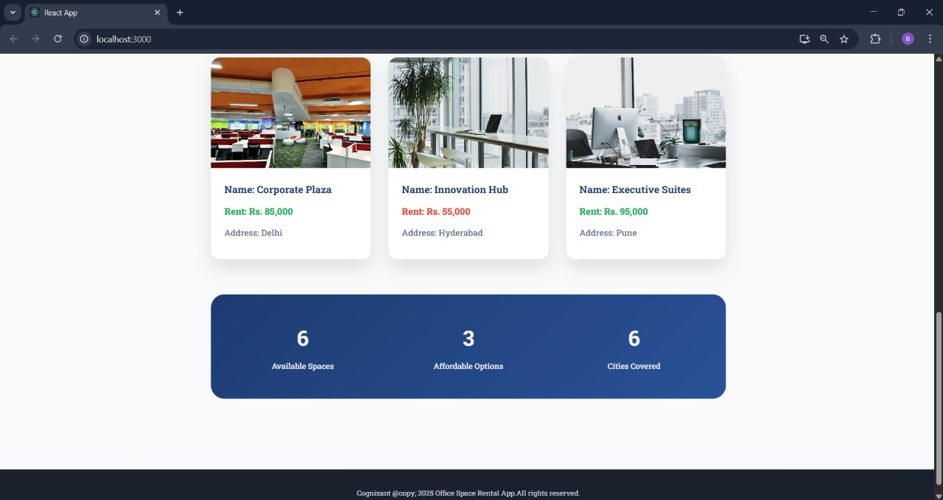

**Exercise 3 : Create Event examples app using React**

**Code:**

**Counter.js:**

import {Component} from 'react';

class Counter extends Component{

constructor(props){

super(props);

this.state={

count: 0

};

}

incrementCounter=()=>{

this.setState(prevState=>({

count:prevState.count+1

}));

}

sayHello=()=>{

alert('Hello! Counter has been incremented!');

}

handleIncrement=()=>{

this.incrementCounter();

this.sayHello();

}

handleDecrement=()=>{

this.setState(prevState=>({

count:prevState.count-1

}));

alert('Counter has been decremented!');

}

render(){

return(

<div className="component-card">

<h2>Counter Component</h2>

<div className="counter-display">

<h3>Count: {this.state.count}</h3>

</div>

<div className="button-group">

<button className="btn btn-primary" onClick={this.handleIncrement}>

Increment

</button>

<button className="btn btn-danger" onClick={this.handleDecrement}>

Decrement

</button>

</div>

</div>

);

}

}

export default Counter;

**SyntheticEventButton.js:**

import {Component} from 'react';

class SyntheticEventButton extends Component{

constructor(props){

super(props);

this.state={};

}

handleOnPress=(e)=>{

console.log('Synthetic Event:', e);

console.log('Event Type:', e.type);

console.log('Target:', e.target);

console.log('Current Target:', e.currentTarget);

console.log('Timestamp:', e.timeStamp);

alert('I was clicked!');

}

render(){

return(

<div className="component-card">

<h2>Synthetic Event Handler</h2>

<div className="button-group">

<button className="btn btn-synthetic" onClick={this.handleOnPress}>

Click on me

</button>

</div>

</div>

);

}

}

export default SyntheticEventButton;

**CurrencyConverter.js**

import {Component} from 'react';

class CurrencyConverter extends Component{

constructor(props){

super(props);

this.state={

amount: '',

currency: ''

};

}

handleInputChange=(e)=>{

const {name,value}=e.target;

this.setState({

[name]: value

});

}

handleSubmit=(e)=>{

e.preventDefault();

const {amount,currency}=this.state;

if(!amount || !currency){

alert('Please fill in both fields');

return;

}

let convertedAmount;

const numAmount=parseFloat(amount);

if(isNaN(numAmount)){

alert('Please enter a valid number for amount');

return;

}

if(currency.toLowerCase()==='rupees' || currency.toLowerCase()==='inr'){

convertedAmount=(numAmount/90).toFixed(2);

alert(Conversion Result:\n₹${numAmount} = €${convertedAmount});

}else if(currency.toLowerCase()==='euro' || currency.toLowerCase()==='eur'){

convertedAmount=(numAmount*90).toFixed(2);

alert(Conversion Result:\n€${numAmount} = ₹${convertedAmount});

}else{

alert('Please enter "Rupees" or "Euro" as currency');

}

}

render(){

return(

<div className="component-card">

<h2>Currency Converter!!!</h2>

<form onSubmit={this.handleSubmit} className="converter-form">

<div className="form-group">

<label>Amount:</label>

<input type="number" name="amount" value={this.state.amount} onChange={this.handleInputChange} className="form-input" placeholder="Enter amount"/>

</div>

<div className="form-group">

<label>Currency:</label>

<input type="text" name="currency" value={this.state.currency} onChange={this.handleInputChange} className="form-input" placeholder="Rupees or Euro"/>

</div>

<button type="submit" className="btn btn-convert">

Convert

</button>

</form>

</div>

);

}

}

export default CurrencyConverter;

**WelcomeButton.js:**

import {Component} from 'react';

class WelcomeButton extends Component{

constructor(props){

super(props);

this.state={};

}

handleWelcomeClick = () => {

alert('You clicked the welcome button!');

}

render(){

return(

<div className="component-card">

<h2>Welcome Component</h2>

<div className="welcome-button-container">

<button className="btn btn-welcome" onClick={this.handleWelcomeClick}>

Say Welcome

</button>

</div>

</div>

);

}

}

export default WelcomeButton;

**App.js:**

import {Component} from 'react';

import './App.css';

import Counter from './components/Counter';

import WelcomeButton from './components/WelcomeButton';

import SyntheticEventButton from './components/SyntheticEventButton';

import CurrencyConverter from './components/CurrencyConverter';

class App extends Component{

constructor(props){

super(props);

this.state={

showWelcomePopup: false

};

}

componentDidMount(){

setTimeout(()=>{

this.setState({showWelcomePopup:false});

},4000);

}

closePopup=()=>{

this.setState({showWelcomePopup:false});

}

render(){

return(

<div className="App">

<header className="app-header">

<h1>React Event Handling </h1>

</header>

<main className="app-main">

<div className="top-row">

<Counter/>

<WelcomeButton/>

</div>

<div className="bottom-row">

<SyntheticEventButton/>

<CurrencyConverter/>

</div>

</main>

</div>

);

}

}

export default App;

**App.css:**

@import url('https://fonts.googleapis.com/css2?family=Roboto+Slab:wght@300;400;500;700&display=swap');

:root{

--navy-blue: #1e3a8a;

--light-navy: var(--navy-blue);

--dark-navy: #1e40af;

--white: #ffffff;

--light-gray: #f8fafc;

--border-gray: #e2e8f0;

--success-green: #10b981;

--danger-red: #ef4444;

--warning-orange: #f59e0b;

}

*{

margin: 0;

padding: 0;

box-sizing: border-box;

}

body{

font-family: 'Roboto Slab', serif;

background: linear-gradient(135deg, var(--navy-blue) 0%, var(--light-navy) 100%);

min-height: 100vh;

color: var(--white);

}

.App{

min-height: 100vh;

position: relative;

}

.popup-overlay{

position: fixed;

top: 0;

left: 0;

width: 100vw;

height: 100vh;

background: rgba(0, 0, 0, 0.3);

display: flex;

justify-content: center;

align-items: center;

z-index: 9999;

animation: fadeInOverlay 0.2s ease-out;

}

.popup-modal{

background: #ffffff;

border: 1px solid #d4d4d4;

border-radius: 0;

box-shadow: 0 4px 12px rgba(0, 0, 0, 0.15);

width: 400px;

max-width: 90%;

font-family: -apple-system, BlinkMacSystemFont, 'Segoe UI', Roboto, sans-serif;

animation: slideInModal 0.2s ease-out;

}

.popup-header{

background: #f0f0f0;

padding: 8px 16px;

border-bottom: 1px solid #d4d4d4;

font-size: 13px;

font-weight: 400;

color: #333333;

text-align: left;

}

.popup-content{

padding: 20px 16px;

min-height: 60px;

display: flex;

align-items: center;

}

.popup-message{

font-size: 13px;

color: #333333;

line-height: 1.4;

text-align: left;

font-weight: 400;

word-wrap: break-word;

}

.popup-footer{

padding: 12px 16px;

display: flex;

justify-content: flex-end;

border-top: 1px solid #e5e5e5;

background: #fafafa;

}

.popup-ok-button{

background: #4285f4;

color: white;

border: none;

padding: 6px 16px;

font-size: 13px;

font-weight: 500;

border-radius: 2px;

cursor: pointer;

font-family: -apple-system, BlinkMacSystemFont, 'Segoe UI', Roboto, sans-serif;

transition: background-color 0.2s ease;

text-transform: none;

letter-spacing: normal;

min-width: 65px;

}

.popup-ok-button:hover{

background: #3367d6;

}

.popup-ok-button:active{

background: #2a56c6;

}

.welcome-overlay{

position: fixed;

top: 0;

left: 0;

width: 100vw;

height: 100vh;

background: rgba(0, 0, 0, 0.3);

display: flex;

justify-content: center;

align-items: center;

z-index: 9999;

animation: fadeInOverlay 0.2s ease-out;

}

.welcome-modal{

background: #ffffff;

border: 1px solid #d4d4d4;

border-radius: 0;

box-shadow: 0 4px 12px rgba(0, 0, 0, 0.15);

width: 400px;

font-family: -apple-system, BlinkMacSystemFont, 'Segoe UI', Roboto, sans-serif;

animation: slideInModal 0.2s ease-out;

}

.modal-header{

background: #f0f0f0;

padding: 8px 16px;

border-bottom: 1px solid #d4d4d4;

font-size: 13px;

font-weight: 400;

color: #333333;

text-align: left;

}

.modal-content{

padding: 20px 16px;

min-height: 60px;

display: flex;

align-items: center;

}

.modal-message{

font-size: 13px;

color: #333333;

line-height: 1.4;

text-align: left;

font-weight: 400;

}

.modal-footer{

padding: 12px 16px;

display: flex;

justify-content: flex-end;

border-top: 1px solid #e5e5e5;

background: #fafafa;

}

.ok-button{

background: #4285f4;

color: white;

border: none;

padding: 6px 16px;

font-size: 13px;

font-weight: 500;

border-radius: 2px;

cursor: pointer;

font-family: -apple-system, BlinkMacSystemFont, 'Segoe UI', Roboto, sans-serif;

transition: background-color 0.2s ease;

text-transform: none;

letter-spacing: normal;

min-width: 65px;

}

.ok-button:hover{

background: #3367d6;

transform: none;

box-shadow: none;

}

.ok-button:active{

background: #2a56c6;

}

@keyframes fadeInOverlay{

from{

opacity: 0;

}

to{

opacity: 1;

}

}

@keyframes slideInModal{

from{

transform: scale(0.95);

opacity: 0;

}

to{

transform: scale(1);

opacity: 1;

}

}

.loading-spinner{

width: 40px;

height: 40px;

border: 4px solid var(--border-gray);

border-top: 4px solid var(--navy-blue);

border-radius: 50%;

animation: spin 1s linear infinite;

margin: 0 auto;

}

@keyframes spin{

0%{

transform: rotate(0deg);

}

100%{

transform: rotate(360deg);

}

}

@keyframes slideIn{

from{

transform: translateY(-50px);

opacity: 0;

}

to{

transform: translateY(0);

opacity: 1;

}

}

.app-header{

text-align: center;

padding: 2rem 1rem;

background: rgba(255, 255, 255, 0.1);

backdrop-filter: blur(10px);

margin-bottom: 2rem;

}

.app-header h1{

font-size: 2.5rem;

font-weight: 700;

margin-bottom: 0.5rem;

text-shadow: 2px 2px 4px rgba(0, 0, 0, 0.3);

}

.app-header p{

font-size: 1.2rem;

font-weight: 300;

opacity: 0.9;

}

.app-main{

max-width: 1200px;

margin: 0 auto;

padding: 0 1rem;

}

.top-row,

.bottom-row{

display: grid;

grid-template-columns: 1fr 1fr;

gap: 2rem;

margin-bottom: 2rem;

}

.component-card{

background: var(--white);

color: var(--navy-blue);

padding: 2rem;

border-radius: 15px;

box-shadow: 0 10px 30px rgba(0, 0, 0, 0.2);

transition: transform 0.3s ease, box-shadow 0.3s ease;

position: relative;

overflow: hidden;

min-height: 300px;

display: flex;

flex-direction: column;

}

.component-card:hover{

transform: translateY(-5px);

box-shadow: 0 20px 40px rgba(0, 0, 0, 0.3);

}

.component-card::before{

content: '';

position: absolute;

top: 0;

left: 0;

right: 0;

height: 4px;

background: linear-gradient(90deg, var(--navy-blue), var(--light-navy));

}

.component-card h2{

font-size: 1.5rem;

font-weight: 700;

margin-bottom: 1.5rem;

text-align: center;

color: var(--navy-blue);

}

.counter-display{

text-align: center;

margin: 1rem 0;

}

.counter-display h3{

font-size: 2rem;

font-weight: 500;

color: var(--navy-blue);

padding: 1rem;

background: var(--light-gray);

border-radius: 10px;

border: 2px solid var(--border-gray);

}

.button-group{

display: flex;

gap: 1rem;

justify-content: center;

flex-wrap: wrap;

}

.welcome-button-container,

.synthetic-button-container{

display: flex;

justify-content: center;

align-items: center;

flex: 1;

}

.btn{

padding: 0.75rem 1.5rem;

border: none;

border-radius: 8px;

font-family: 'Roboto Slab', serif;

font-size: 1rem;

font-weight: 500;

cursor: pointer;

transition: all 0.3s ease;

text-transform: uppercase;

letter-spacing: 0.5px;

min-width: 120px;

}

.btn:hover{

transform: translateY(-2px);

box-shadow: 0 5px 15px rgba(0, 0, 0, 0.3);

}

.btn-primary{

background: var(--navy-blue);

color: var(--white);

}

.btn-primary:hover{

background: var(--dark-navy);

}

.btn-danger{

background: var(--danger-red);

color: var(--white);

}

.btn-danger:hover{

background: #dc2626;

}

.btn-welcome{

margin-top: 50px;

background: var(--success-green);

color: var(--white);

}

.btn-welcome:hover{

background: #059669;

}

.btn-synthetic{

margin-top: 70px;

background: var(--warning-orange);

color: var(--white);

}

.btn-synthetic:hover{

background: #d97706;

}

.btn-convert{

background: var(--light-navy);

color: var(--white);

width: 100%;

}

.btn-convert:hover{

background: var(--navy-blue);

}

.converter-form{

display: flex;

flex-direction: column;

gap: 1rem;

}

.form-group{

display: flex;

flex-direction: column;

gap: 0.5rem;

}

.form-group label{

font-weight: 500;

color: var(--navy-blue);

}

.form-input{

padding: 0.75rem;

border: 2px solid var(--border-gray);

border-radius: 8px;

font-family: 'Roboto Slab', serif;

font-size: 1rem;

transition: border-color 0.3s ease;

}

.form-input:focus{

outline: none;

border-color: var(--navy-blue);

box-shadow: 0 0 0 3px rgba(30, 58, 138, 0.1);

}

@media(max-width:768px){

.top-row,

.bottom-row{

grid-template-columns: 1fr;

gap: 1rem;

}

.app-header h1{

font-size: 2rem;

}

.app-header p{

font-size: 1rem;

}

.component-card{

padding: 1.5rem;

min-height: 250px;

}

.counter-display h3{

font-size: 1.5rem;

}

.button-group{

flex-direction: column;

}

.btn{

width: 100%;

}

}

@media (max-width: 480px){

.app-main{

padding: 0 0.5rem;

}

.component-card{

padding: 1rem;

}

.welcome-modal{

margin: 1rem;

padding: 1.5rem;

}

}

**Output:**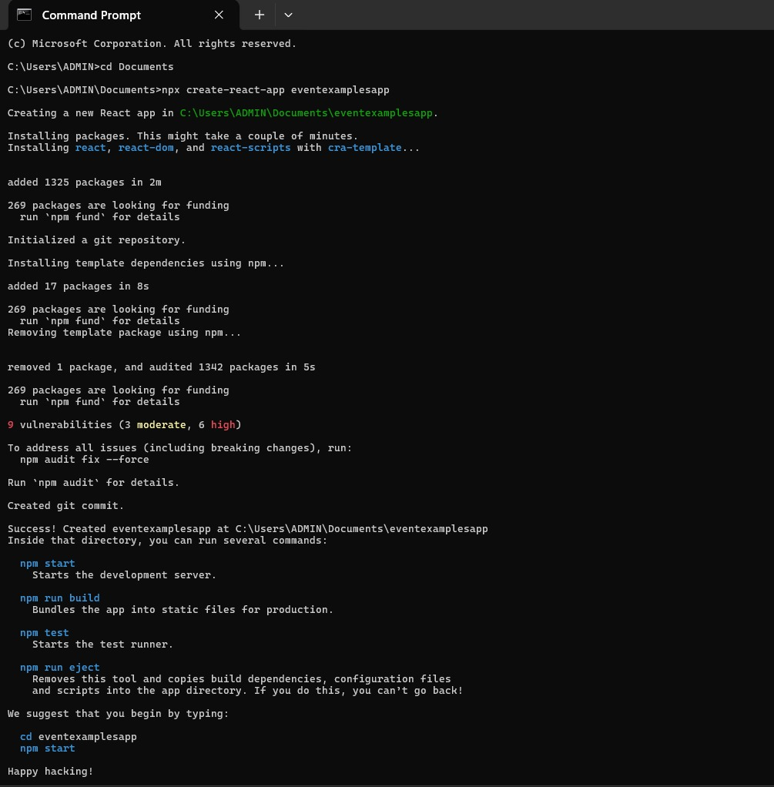

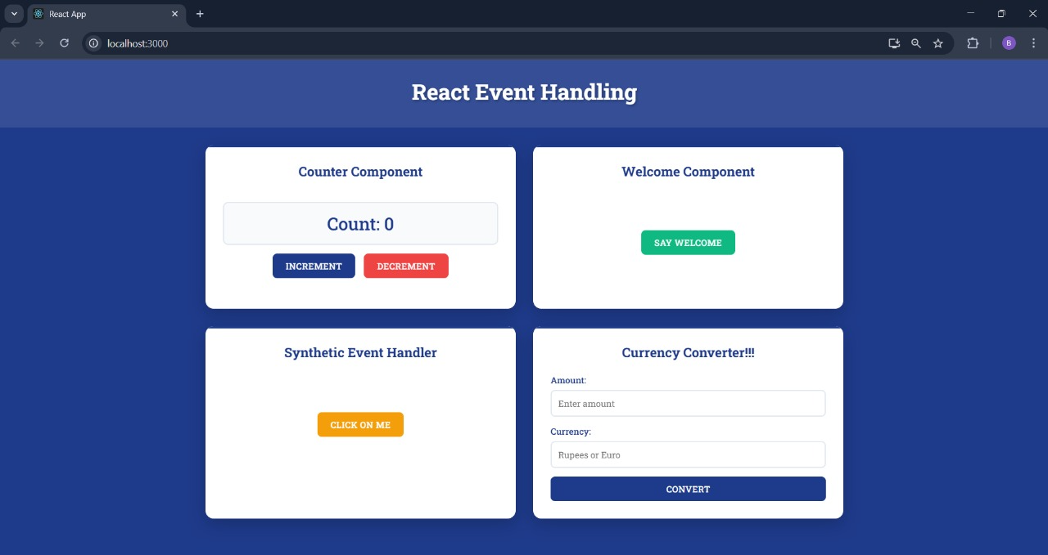

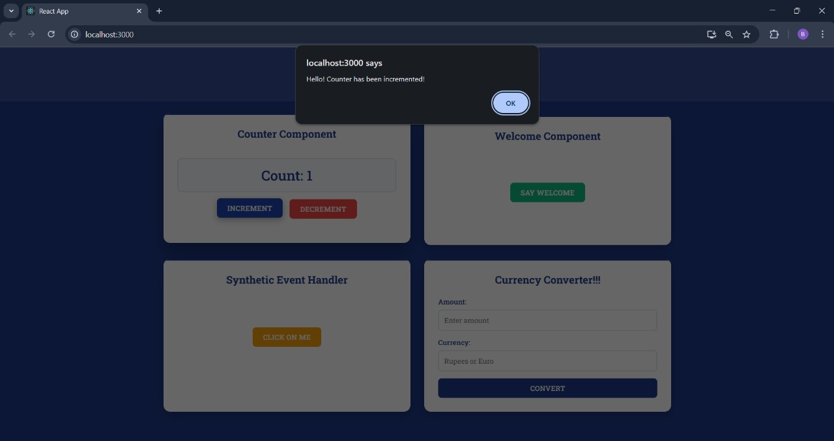

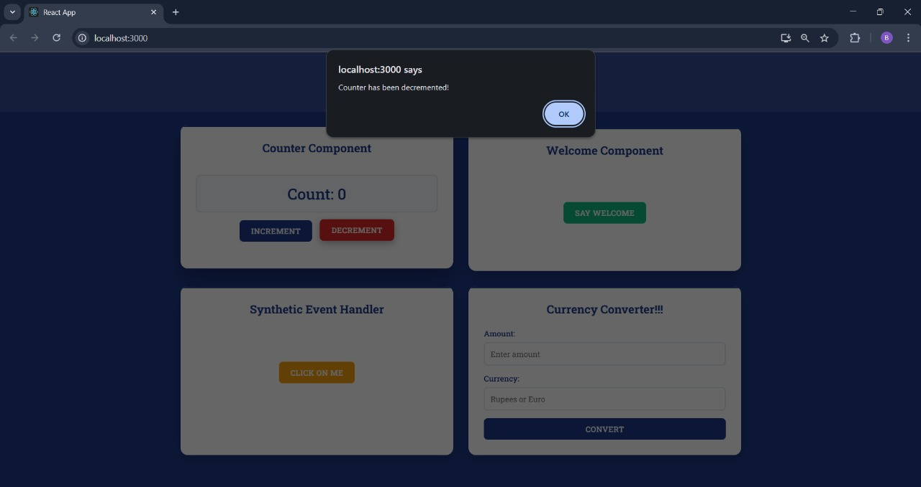

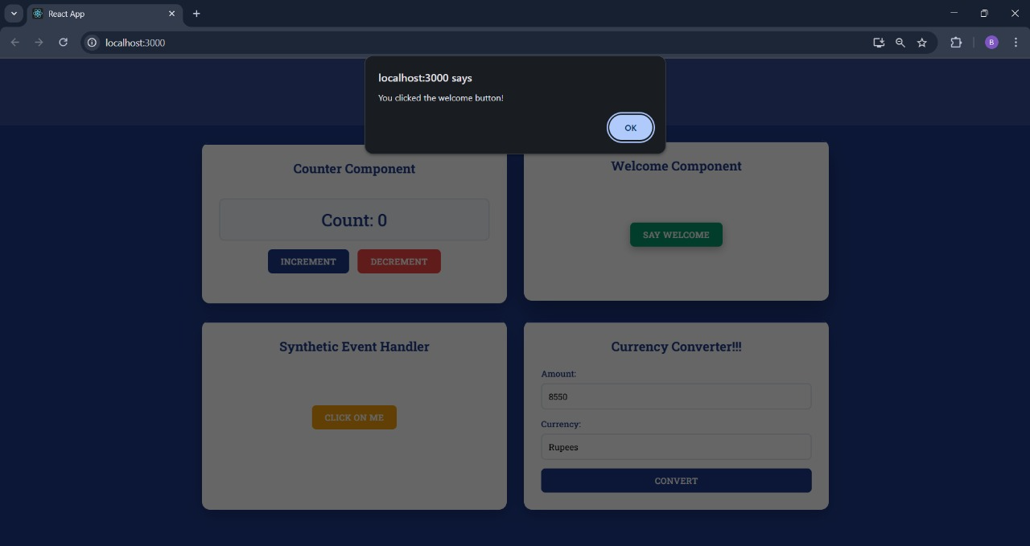

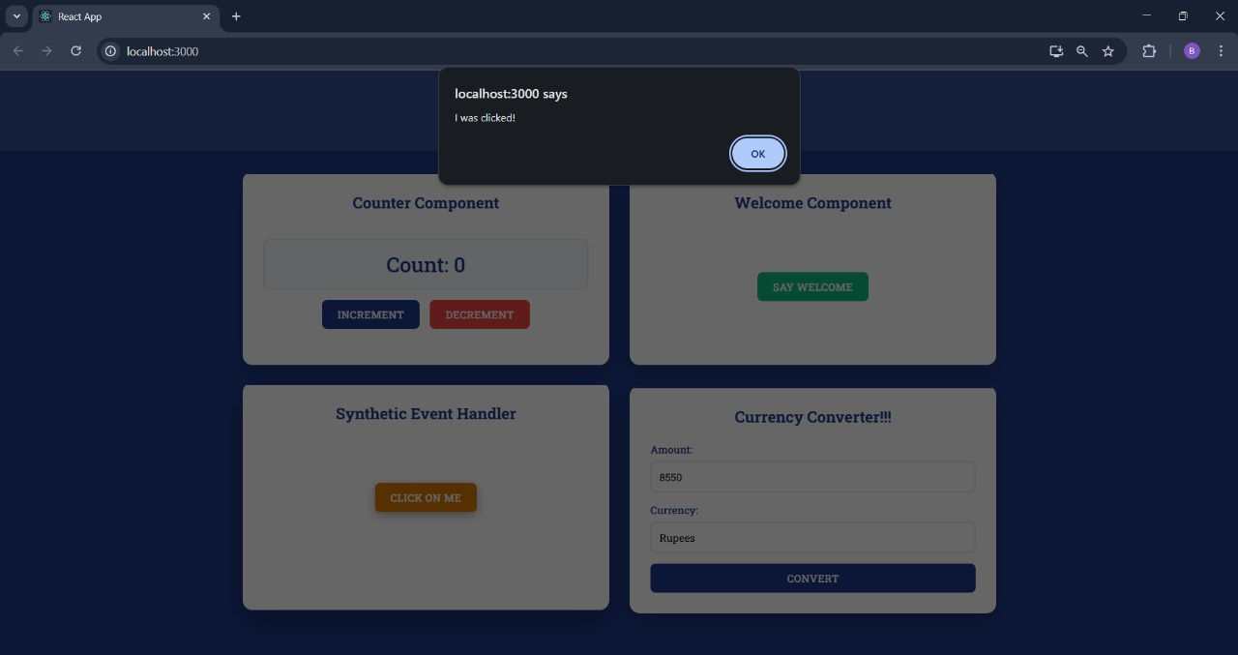

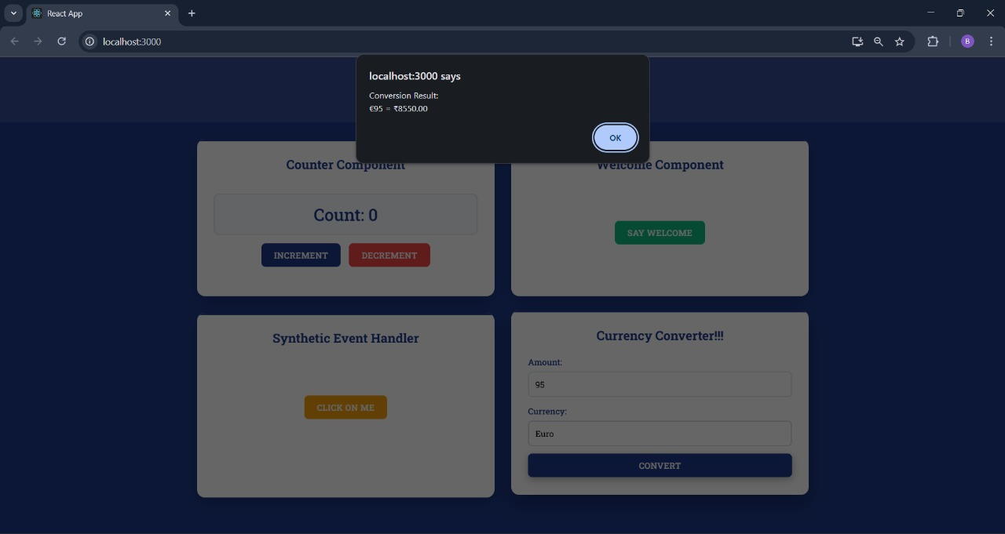

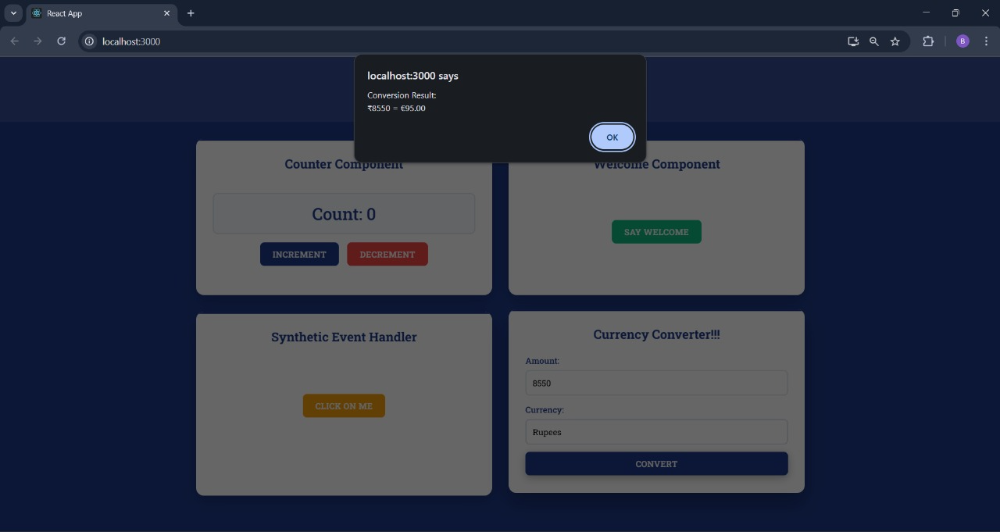

**Exercise 4 : Create ticket booking app using React**

**Code:**

**FlightCard.js:**

import {useState} from 'react';

function FlightCard({flight,canBook}){

const [isBooked,setIsBooked]=useState(false);

const handleBooking=()=>{

if(canBook && !isBooked){

setIsBooked(true);

alert(Ticket booked successfully for ${flight.flightNumber}!);

}

};

return(

<div className="flight-card">

<div className="flight-header">

<h3>{flight.airline}</h3>

<span className="flight-number">{flight.flightNumber}</span>

</div>

<div className="flight-route">

<div className="route-info">

<div className="location">

<span className="city">{flight.from}</span>

<span className="time">{flight.departure}</span>

</div>

<div className="duration">

<div className="duration-line"></div>

<span>{flight.duration}</span>

</div>

<div className="location">

<span className="city">{flight.to}</span>

<span className="time">{flight.arrival}</span>

</div>

</div>

</div>

<div className="flight-details">

<div className="price">

<span className="currency">₹</span>

<span className="amount">{flight.price.toLocaleString()}</span>

</div>

<div className="seats">

<span className="seats-available">{flight.seatsAvailable} seats left</span>

</div>

</div>

<div className="flight-actions">

{canBook ? (

<button className={book-button ${isBooked ? 'booked' : ''}} onClick={handleBooking} disabled={isBooked}>

{isBooked ? 'Booked' : 'Book Now'}

</button>

) : (

<button className="book-button disabled" disabled>

Login to Book

</button>

)}

</div>

</div>

);

}

export default FlightCard;

**Greeting.js:**

import UserGreeting from './UserGreeting';

import GuestGreeting from './GuestGreeting';

function Greeting(props){

const isLoggedIn=props.isLoggedIn;

if(isLoggedIn){

return <UserGreeting/>;

}

return <GuestGreeting/>;

}

export default Greeting;

**GuestGreeting.js:**

import FlightCard from './FlightCard';

import {flightData} from '../data/flightData';

function GuestGreeting(){

return(

<div className="guest-greeting">

<h2>Browse Available Flights</h2>

<p className="guest-subtitle">Please login to book tickets</p>

<div className="flights-grid">

{flightData.map(flight=>(

<FlightCard key={flight.id} flight={flight} canBook={false}/>

))}

</div>

</div>

);

}

export default GuestGreeting;

**UserGreeting.js:**

import FlightCard from './FlightCard';

import {flightData} from '../data/flightData';

function UserGreeting(){

return(

<div className="user-greeting">

<h2>Welcome back Balaji-Book your flights now</h2>

<p className="user-subtitle">You can now book tickets for any available flight</p>

<div className="flights-grid">

{flightData.map(flight=>(

<FlightCard key={flight.id} flight={flight} canBook={true}/>

))}

</div>

</div>

);

}

export default UserGreeting;

**LoginButton.js:**

function LoginButton(props){

return(

<button className="auth-button login-button" onClick={props.onClick}>

Login

</button>

);

}

export default LoginButton;

**LogoutButton.js:**

function LogoutButton(props){

return(

<button className="auth-button logout-button" onClick={props.onClick}>

Logout

</button>

);

}

export default LogoutButton;

**flightdata.js:**

export const flightData=[

{

id: 1,

airline: "Air India",

flightNumber: "AI-101",

from: "Delhi",

to: "Mumbai",

departure: "06:00 AM",

arrival: "08:30 AM",

duration: "2h 30m",

price: 4500,

seatsAvailable: 45

},

{

id: 2,

airline: "IndiGo",

flightNumber: "6E-234",

from: "Bangalore",

to: "Chennai",

departure: "09:15 AM",

arrival: "10:45 AM",

duration: "1h 30m",

price: 3200,

seatsAvailable: 23

}

];

**App.css:**

@import url('https://fonts.googleapis.com/css2?family=Roboto+Slab:wght@300;400;500;600;700&display=swap');

*{

margin: 0;

padding: 0;

box-sizing: border-box;

}

body{

font-family: 'Roboto Slab', serif;

background: linear-gradient(135deg, #1e3c72 0%, #2a5298 100%);

min-height: 100vh;

color: #333;

}

.App{

min-height: 100vh;

display: flex;

flex-direction: column;

}

.app-header{

background: rgba(255, 255, 255, 0.95);

backdrop-filter: blur(10px);

border-bottom: 1px solid rgba(30, 60, 114, 0.1);

padding: 1rem 0;

position: sticky;

top: 0;

z-index: 100;

box-shadow: 0 2px 20px rgba(0, 0, 0, 0.1);

}

.header-content{

max-width: 1200px;

margin: 0 auto;

padding: 0 2rem;

display: flex;

justify-content: space-between;

align-items: center;

}

.app-title{

font-size: 2.5rem;

font-weight: 700;

color: #1e3c72;

text-shadow: 2px 2px 4px rgba(0, 0, 0, 0.1);

}

.auth-section{

display: flex;

align-items: center;

}

.auth-button{

padding: 12px 30px;

border: none;

border-radius: 50px;

font-family: 'Roboto Slab', serif;

font-weight: 600;

font-size: 1rem;

cursor: pointer;

transition: all 0.3s ease;

text-transform: uppercase;

letter-spacing: 0.5px;

box-shadow: 0 4px 15px rgba(0, 0, 0, 0.2);

}

.login-button{

background: linear-gradient(45deg, #1e3c72, #2a5298);

color: white;

}

.login-button:hover{

background: linear-gradient(45deg, #2a5298, #1e3c72);

transform: translateY(-2px);

box-shadow: 0 6px 20px rgba(0, 0, 0, 0.3);

}

.logout-button{

background: linear-gradient(45deg, #dc3545, #c82333);

color: white;

}

.logout-button:hover{

background: linear-gradient(45deg, #c82333, #dc3545);

transform: translateY(-2px);

box-shadow: 0 6px 20px rgba(220, 53, 69, 0.4);

}

.main-content{

flex: 1;

max-width: 1200px;

margin: 0 auto;

padding: 3rem 2rem;

width: 100%;

}

.user-greeting h2,

.guest-greeting h2{

font-size: 2.5rem;

font-weight: 600;

text-align: center;

margin-bottom: 1rem;

color: white;

text-shadow: 2px 2px 4px rgba(0, 0, 0, 0.3);

}

.user-subtitle,

.guest-subtitle{

text-align: center;

font-size: 1.2rem;

color: rgba(255, 255, 255, 0.9);

margin-bottom: 3rem;

font-weight: 300;

}

.flights-grid{

display: grid;

grid-template-columns: repeat(auto-fit, minmax(400px, 1fr));

gap: 2rem;

margin-top: 2rem;

}

.flight-card{

background: rgba(255, 255, 255, 0.95);

backdrop-filter: blur(10px);

border-radius: 20px;

padding: 2rem;

box-shadow: 0 10px 30px rgba(0, 0, 0, 0.2);

transition: all 0.3s ease;

border: 1px solid rgba(255, 255, 255, 0.2);

}

.flight-card:hover{

transform: translateY(-5px);

box-shadow: 0 15px 40px rgba(0, 0, 0, 0.3);

}

.flight-header{

display: flex;

justify-content: space-between;

align-items: center;

margin-bottom: 1.5rem;

padding-bottom: 1rem;

border-bottom: 2px solid #e9ecef;

}

.flight-header h3{

font-size: 1.5rem;

font-weight: 600;

color: #1e3c72;

}

.flight-number{

background: linear-gradient(45deg, #1e3c72, #2a5298);

color: white;

padding: 0.5rem 1rem;

border-radius: 25px;

font-weight: 600;

font-size: 0.9rem;

}

.flight-route{

margin-bottom: 1.5rem;

}

.route-info{

display: flex;

align-items: center;

justify-content: space-between;

}

.location{

display: flex;

flex-direction: column;

align-items: center;

flex: 1;

}

.city{

font-size: 1.2rem;

font-weight: 600;

color: #1e3c72;

margin-bottom: 0.5rem;

}

.time{

font-size: 1rem;

color: #6c757d;

font-weight: 500;

}

.duration{

display: flex;

flex-direction: column;

align-items: center;

flex: 1;

position: relative;

}

.duration-line{

width: 100px;

height: 2px;

background: linear-gradient(90deg, #1e3c72, #2a5298);

margin-bottom: 0.5rem;

position: relative;

}

.duration-line::after{

position: absolute;

right: -10px;

top: -10px;

font-size: 1rem;

}

.duration span{

font-size: 0.9rem;

color: #6c757d;

font-weight: 500;

}

.flight-details{

display: flex;

justify-content: space-between;

align-items: center;

margin-bottom: 1.5rem;

padding: 1rem;

background: rgba(30, 60, 114, 0.05);

border-radius: 15px;

}

.price{

display: flex;

align-items: baseline;

}

.currency{

font-size: 1.2rem;

color: #1e3c72;

font-weight: 600;

margin-right: 0.2rem;

}

.amount{

font-size: 2rem;

font-weight: 700;

color: #1e3c72;

}

.seats-available{

font-size: 0.9rem;

color: #28a745;

font-weight: 600;

background: rgba(40, 167, 69, 0.1);

padding: 0.5rem 1rem;

border-radius: 20px;

}

.flight-actions{

text-align: center;

}

.book-button{

width: 100%;

padding: 1rem 2rem;

border: none;

border-radius: 50px;

font-family: 'Roboto Slab', serif;

font-weight: 600;

font-size: 1.1rem;

cursor: pointer;

transition: all 0.3s ease;

text-transform: uppercase;

letter-spacing: 0.5px;

}

.book-button:not(.disabled):not(.booked){

background: linear-gradient(45deg, #28a745, #20c997);

color: white;

box-shadow: 0 4px 15px rgba(40, 167, 69, 0.3);

}

.book-button:not(.disabled):not(.booked):hover{

background: linear-gradient(45deg, #20c997, #28a745);

transform: translateY(-2px);

box-shadow: 0 6px 20px rgba(40, 167, 69, 0.4);

}

.book-button.disabled{

background: #6c757d;

color: white;

cursor: not-allowed;

opacity: 0.7;

}

.book-button.booked{

background: linear-gradient(45deg, #1e3c72, #2a5298);

color: white;

cursor: not-allowed;

}

.app-footer{

background: rgba(255, 255, 255, 0.1);

backdrop-filter: blur(10px);

text-align: center;

padding: 2rem;

color: rgba(255, 255, 255, 0.8);

font-weight: 300;

border-top: 1px solid rgba(255, 255, 255, 0.1);

}

@media(max-width: 768px){

.header-content{

padding: 0 1rem;

flex-direction: column;

gap: 1rem;

}

.app-title{

font-size: 2rem;

}

.main-content{

padding: 2rem 1rem;

}

.user-greeting h2,

.guest-greeting h2{

font-size: 2rem;

}

.flights-grid{

grid-template-columns: 1fr;

gap: 1.5rem;

}

.flight-card{

padding: 1.5rem;

}

.route-info{

flex-direction: column;

gap: 1rem;

}

.duration-line{

width: 60px;

transform: rotate(90deg);

}

.flight-details{

flex-direction: column;

gap: 1rem;

text-align: center;

}

}

@media(max-width:480px){

.flight-card{

padding: 1rem;

}

.flight-header{

flex-direction: column;

gap: 1rem;

text-align: center;

}

.amount{

font-size: 1.5rem;

}

}

**Output:**

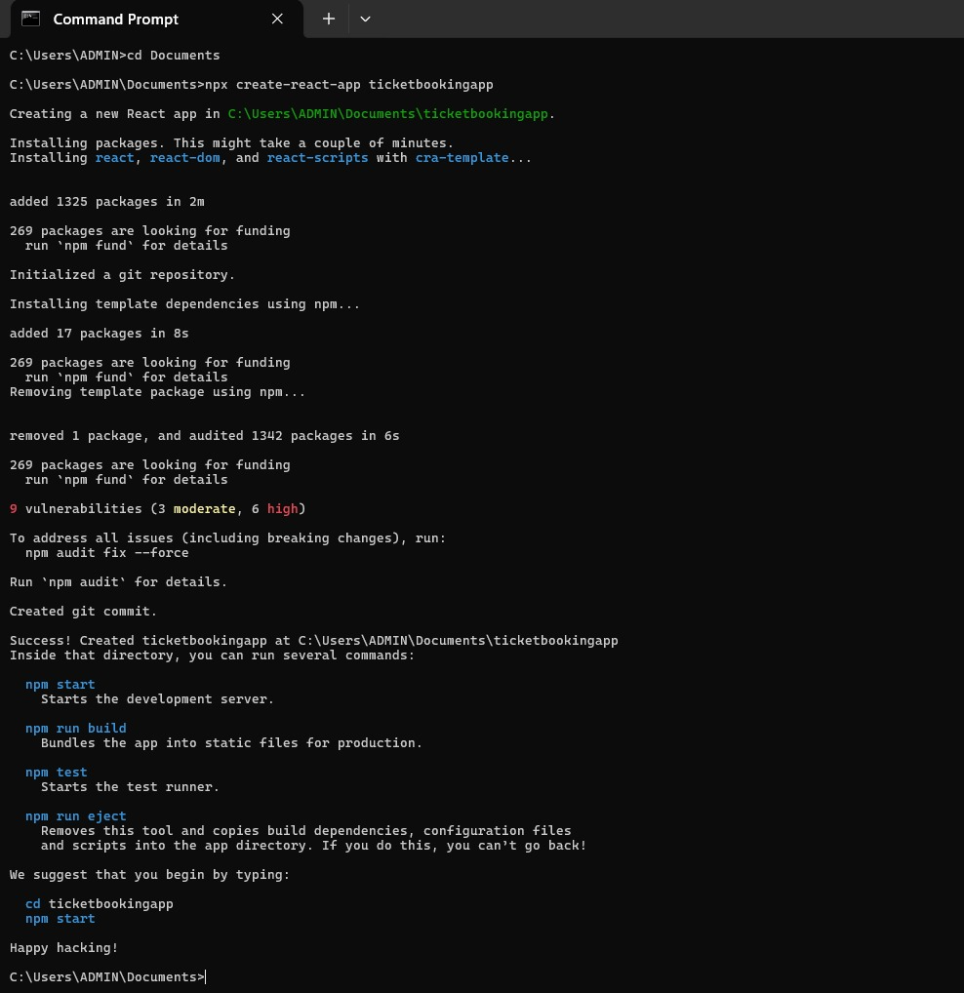

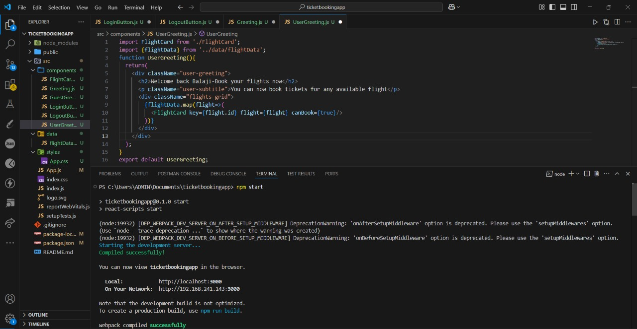

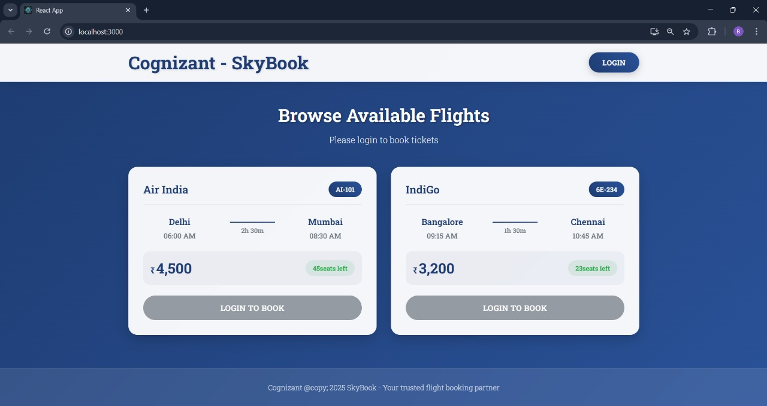

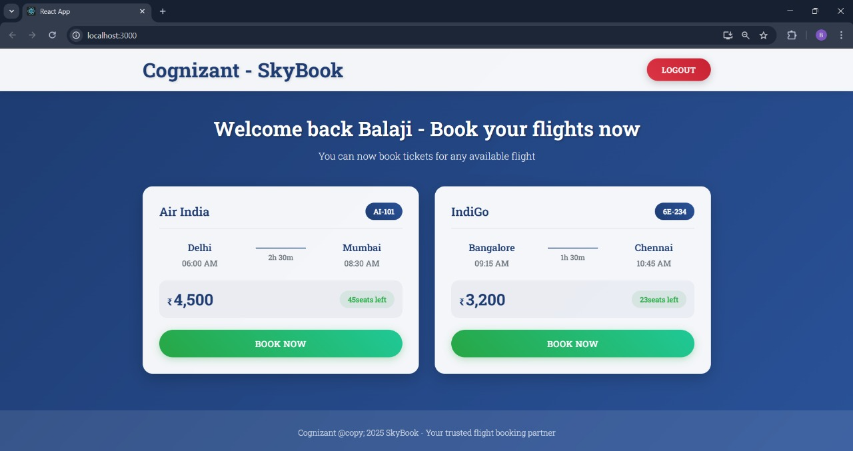

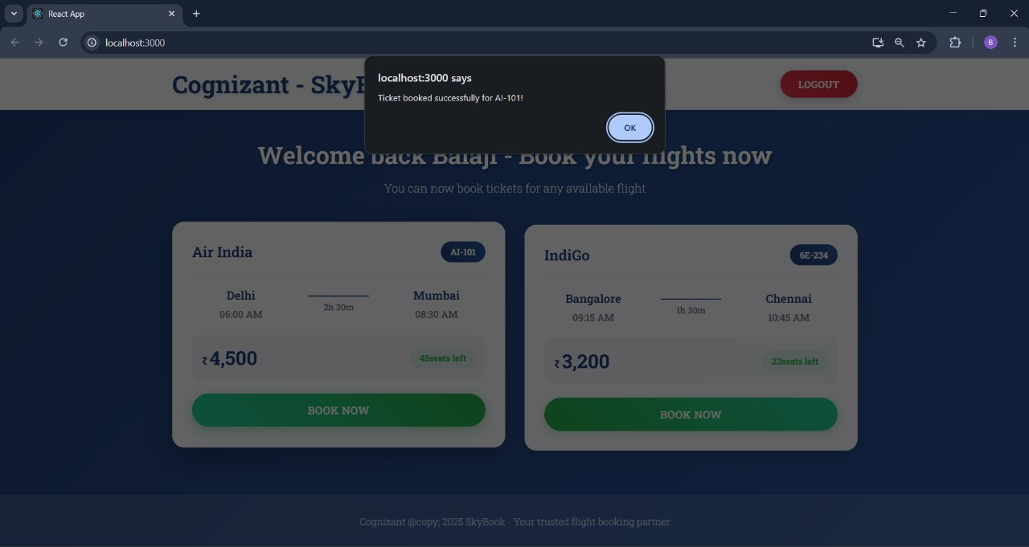

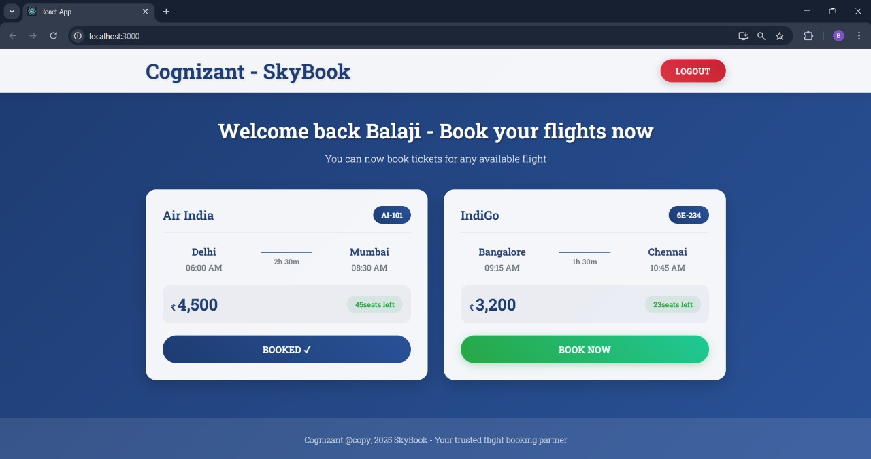

**Exercise 5 : Create Blogger app using React**

**Code:**

**BlogDetails.js:**

const BlogDetails=({blogs})=>{

return(

<ul>

{blogs.map((blog,index)=>(

<div key={index}>

<h3>{blog.title}</h3>

<h4>{blog.author}</h4>

<p>{blog.desc}</p>

</div>

))}

</ul>

);

};

export default BlogDetails;

**BookDetails.js:**

const BookDetails=({books})=>{

return(

<ul>

{books.map((book)=>(

<div key={book.id}>

<h3>{book.bname}</h3>

<h4>{book.price}</h4>

</div>

))}

</ul>

);

};

export default BookDetails;

**CourseDetails.js:**

const CourseDetails=({courses})=>{

return(

<ul>

{courses.map((course,index)=>(

<div key={index}>

<h3>{course.name}</h3>

<h4>{course.date}</h4>

</div>

))}

</ul>

);

};

export default CourseDetails;

**blogs.js:**

export const blogs=[

{title:'React Learning',author:'Stephen Biz',desc:'Welcome to learning React!'},

{title:'Installation',author:'Schwezdenier',desc:'You can install React from npm.'},

];

**books.js:**

export const books=[

{id:101,bname:'Master React',price:670},

{id:102,bname:'Deep Dive into Angular 11',price:800},

{id:103,bname:'Mongo Essentials',price:450},

];

**courses.js:**

export const courses=[

{name:'Angular',date:'4/5/2021'},

{name:'React',date:'6/3/2020'},

];

**App.js:**

import {useState} from 'react';

import './App.css';

import BookDetails from './components/BookDetails';

import BlogDetails from './components/BlogDetails';

import CourseDetails from './components/CourseDetails';

import {books} from './data/books';

import {blogs} from './data/blogs';

import {courses} from './data/courses';

function App(){

const [visible,setVisible]=useState('books');

const renderSection=()=>{

switch(visible){

case 'books':

return <BookDetails books={books}/>;

case 'blogs':

return <BlogDetails blogs={blogs}/>;

case 'courses':

return <CourseDetails courses={courses}/>;

default:

return null;

}

};

return(

<div className="App">

<h1>Blogger App</h1>

<div className="buttons">

<button onClick={()=>setVisible('books')}>Book Details</button>

<button onClick={()=>setVisible('blogs')}>Blog Details</button>

<button onClick={()=>setVisible('courses')}>Course Details</button>

</div>

<div className="content">{renderSection()}</div>

</div>

);

}

export default App;

**App.css:**

body{

margin: 0;

font-family: 'Roboto Slab', serif;

background-color: white;

color: navy;

}

.App{

text-align: center;

padding: 20px;

}

h1{

font-size: 2.5rem;

}

.buttons{

margin-bottom: 30px;

}

button{

margin: 0 10px;

padding: 10px 20px;

font-size: 1rem;

border: 2px solid navy;

background-color: white;

color: navy;

border-radius: 8px;

cursor: pointer;

transition: all 0.3s ease-in-out;

}

button:hover{

background-color: navy;

color: white;

}

.content{

display: flex;

justify-content: center;

gap: 50px;

}

ul{

list-style: none;

padding: 0;

}

div>h3,div>h4,div>p{

margin: 10px 0;

}

**Output:**

